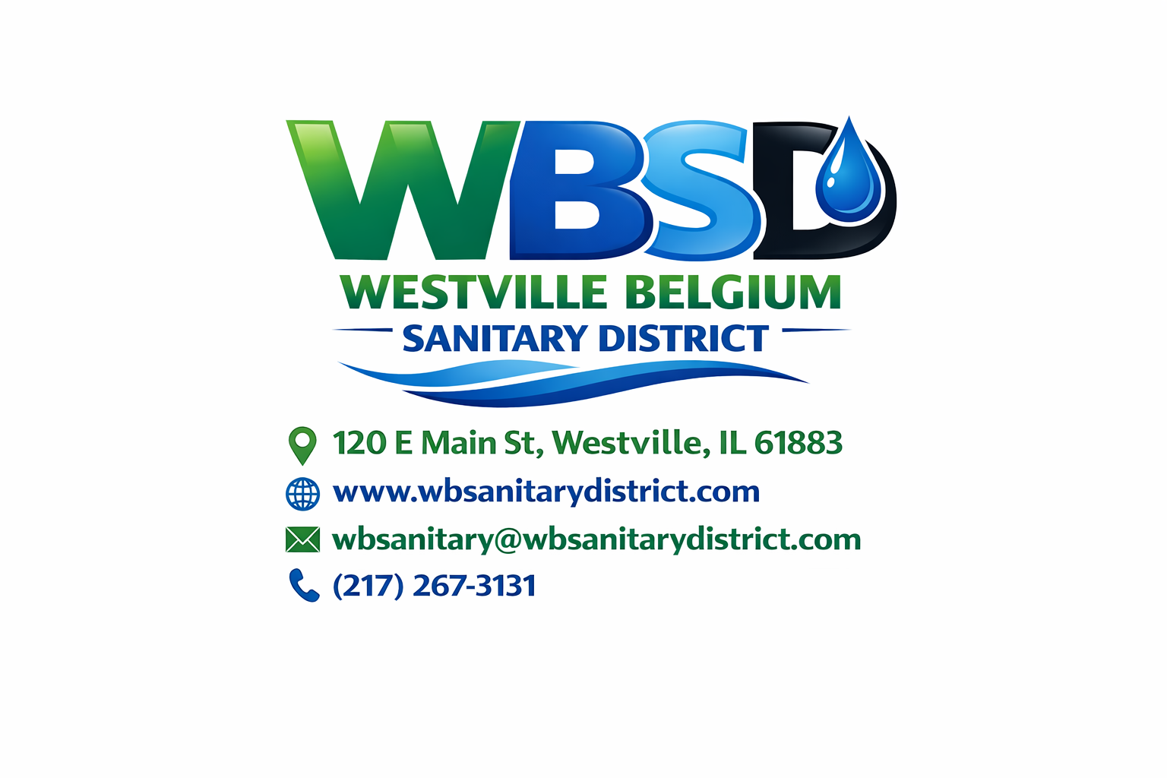
WESTVILLE BELGIUM SANITARY DISTRICT

Public Hearing Agenda
USDA Rural Development Financing Application
Date: January 22, 2026
Time: 5:45 PM
Location:
Westville Belgium Sanitary District
120 E. Main Street
Westville, Illinois

1. Call to Order
The Public Hearing will be called to order by the Chairperson at 5:45 PM.

2. Statement of Purpose
The purpose of this Public Hearing is to inform the public of the Westville Belgium Sanitary District’s intent to apply for financial assistance through the United States Department of Agriculture (USDA) Rural Development Program for proposed wastewater system improvements and to provide an opportunity for public comment.

3. Description of Proposed Project and Financing
Presentation of the proposed project, including:
- Description of the wastewater system improvements
- Estimated total project cost
- Proposed method of financing through USDA Rural Development
Presenter: Larry Johnson, District Engineer

4. Public Comment and Questions
Members of the public are invited to submit questions and comments regarding the proposed project and financing application.
- All questions and comments will be addressed by Larry Johnson and the Board of Trustees, as appropriate
- ⏱ Comments limited to four (4) minutes per person

5. Board Consideration and Responses
The Board of Trustees will consider public comments and provide responses or clarification as necessary.

6. Closure of Public Hearing
Formal closure of the Public Hearing.

Notice of Recording
This Public Hearing will be recorded to ensure accurate documentation for the USDA Rural Development application file and for meeting records. By participating, individuals consent to being recorded. Any concerns should be addressed with the Chairperson prior to the hearing.

