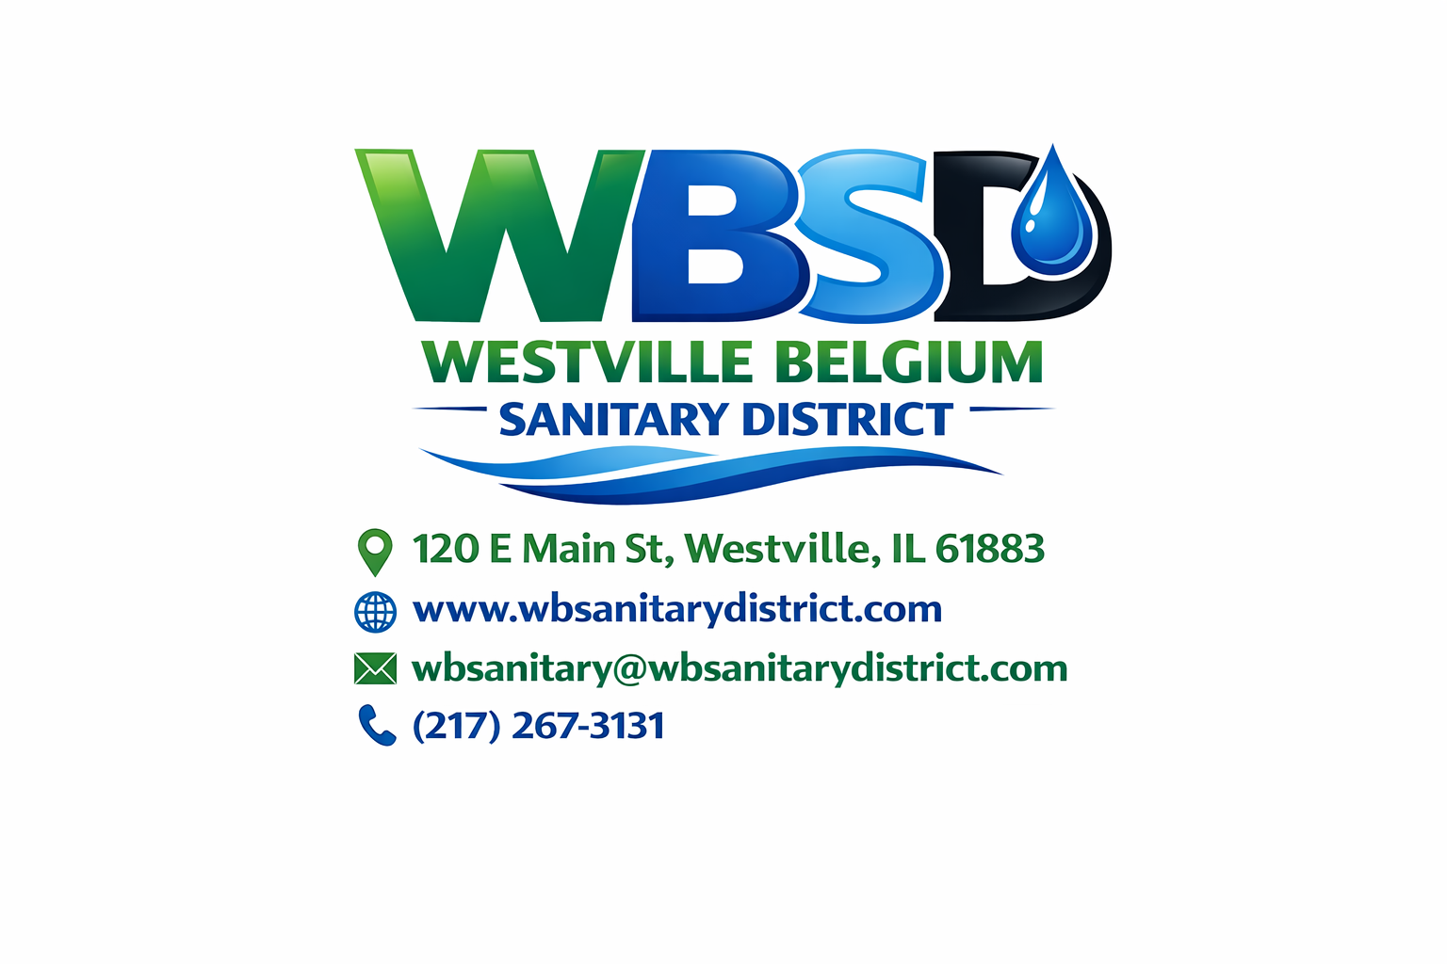
Westville Belgium Sanitary District
Board Meeting Agenda
📅 Date: Thursday, January 22, 2026
🕕 Time: 6:00 PM
📍 Location: 120 E. Main St, Westville, IL 61883

WESTVILLE BELGIUM SANITARY DISTRICT

Board of Trustees Meeting Agenda
January 22, 2026

1. Call to Order

2. Roll Call
- Royce Wolfe
- Bruce Cappello
- Tom Moody
Introduction of Special Guests and Their Reasons for Attending

3. Public Comment
Opportunity for community members to comment on District business
⏱ Limited to four (4) minutes per person

4. Approval of Minutes
Motion to approve the December 18, 2025 Board Meeting Minutes
- Roll Call
- Vote: Yay / Nay

5. Consideration of the Agenda
Motion to approve the January 22, 2026 Meeting Agenda
- Roll Call
- Vote: Yay / Nay

6. Treasurer’s Report
Motion to approve the Treasurer’s Financial Report, including monthly expenditures and summaries
- Roll Call
- Vote: Yay / Nay

7. ERH Report
Motion to approve the ERH Report
- Roll Call
- Vote: Yay / Nay

8. Superintendent’s Report
Motion to approve the Superintendent’s Report
- Roll Call
- Vote: Yay / Nay

9. Office Manager’s Report
Motion to approve the Office Manager’s Report
- Roll Call
- Vote: Yay / Nay

10. New Business
- Jon Anderson – Sewer line relining discussion, Q&A, and PowerPoint presentation

11. Unfinished Business
- Review by Larry Johnson regarding the District’s loan applications, including:
  - Current status of the EPA Loan
  - Current status of the USDA-RD Loan
  - Projected next steps

12. Special Announcements

13. Adjournment

Notice of Recording
This meeting will be recorded using Owl Conferencing Technology to ensure accurate minutes and for future reference. By participating in this meeting, you consent to being recorded. Any concerns should be addressed with the Chairperson prior to the meeting.

