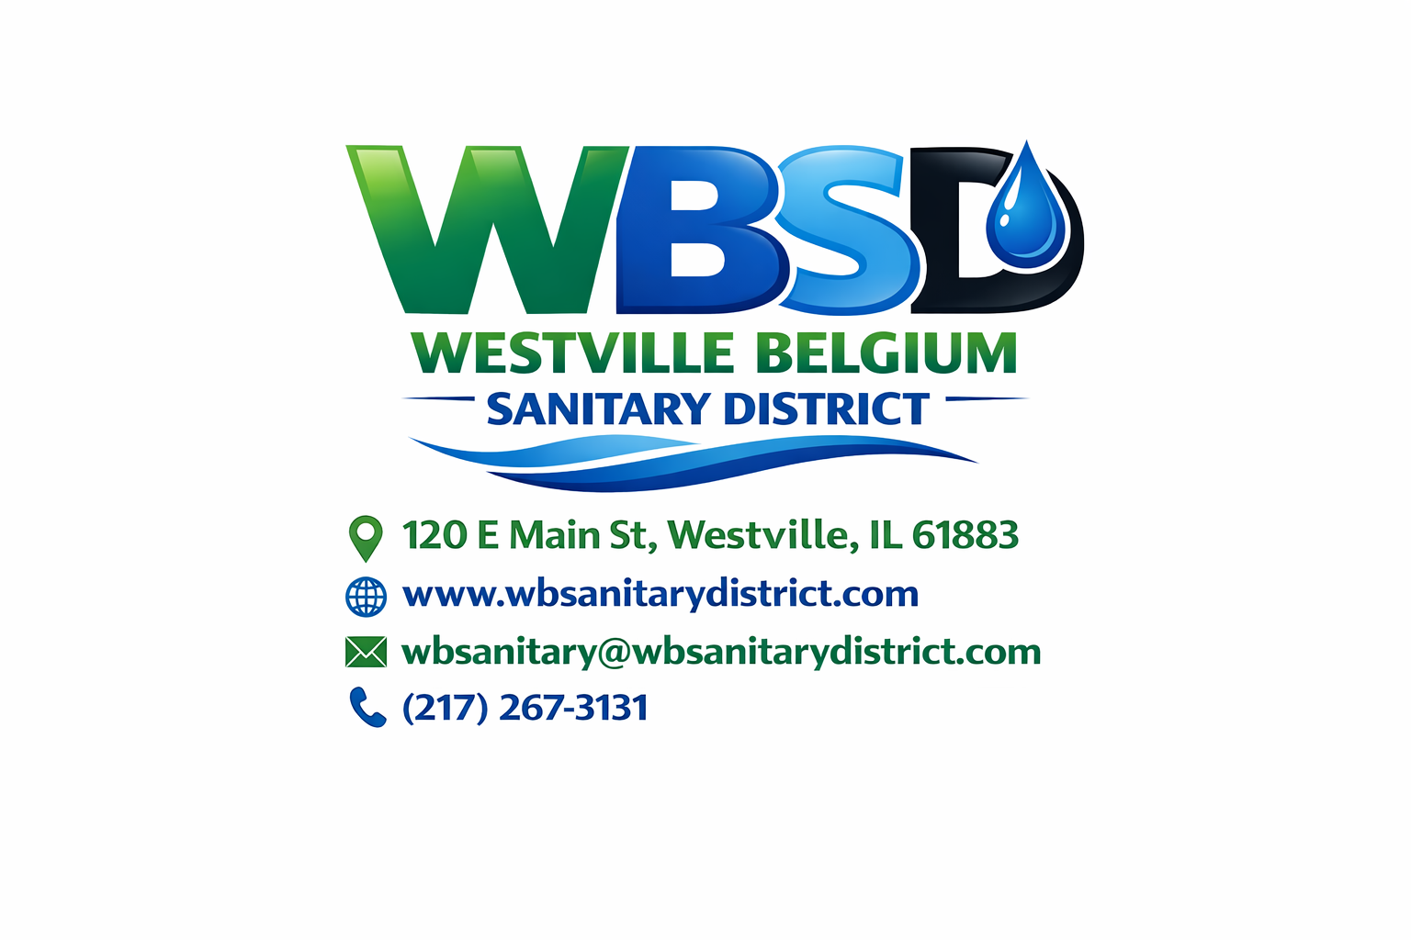

WESTVILLE BELGIUM SANITARY DISTRICT

Board of Trustees Meeting Agenda
📅 Thursday, February 19, 2026
🕕 6:00 PM
📍 120 E. Main St., Westville, IL 61883

1. Call to Order

2. Roll Call
- Royce Wolfe
- Bruce Cappello
- Tom Moody
Introduction of Special Guests and Purpose of Attendance

3. Public Comment
Opportunity for community members to comment on District business.
⏱ Limited to four (4) minutes per person.

4. Approval of Minutes
Motion: Approve the January 22, 2026 Board Meeting Minutes
- Roll Call
- Vote: Yay / Nay
Motion: Approve the January 22, 2026 Public Meeting Minutes
- Roll Call
- Vote: Yay / Nay

5. Consideration of Agenda
Motion: Approve the February 19, 2026 Meeting Agenda
- Roll Call
- Vote: Yay / Nay

6. Treasurer’s Report
Motion: Approve the Treasurer’s Financial Report, including monthly expenditures and summaries
- Roll Call
- Vote: Yay / Nay

7. ERH Report
Motion: Approve the ERH Report
- Roll Call
- Vote: Yay / Nay

8. Superintendent’s Report
Motion: Approve the Superintendent’s Report
- Roll Call
- Vote: Yay / Nay

9. Office Manager’s Report
Motion: Approve the Office Manager’s Report
- Roll Call
- Vote: Yay / Nay

10. ERH / Superintendent Discussion
- Discussion with Jon Anderson regarding sewer line relining (Q&A and PowerPoint presentation planned for March meeting)
- Relining projects: Locust Street and Country Lane
- Request for incident/accident report from ERH regarding fall involving Butch Roseman at the plant on Monday, January 19, 2026
- Discussion of clarifier damage and insurance claim

11. New Business

A. Resolution – Lien and Water Shut-Off Authorization
Consideration and approval of a standing resolution authorizing the President and Office Manager/Treasurer to initiate lien and water shut-off procedures for accounts exceeding six (6) months past due or balances exceeding $350.00, in accordance with District policy and Illinois law, including authorization to include:
- Original balance
- Vermilion County Recorder filing fees
- Certified mail costs at current rates at time of filing
Roll Call
Vote: Yay / Nay

B. Resolution – USDA / EPA Authorized Representatives
Consideration and approval of a resolution authorizing President Royce Wolfe and Treasurer/Office Manager Deanna Simmonds to act as Authorized Representatives and execute all documents necessary for USDA and EPA loan and grant funding, including applications, certifications, agreements, and related paperwork.
Roll Call
Vote: Yay / Nay

12. Unfinished Business
Review by Larry Johnson regarding District loan applications:
- Current status of EPA Loan
- Current status of USDA-RD Loan
- Projected next steps

13. Special Announcements
- CMOM Meeting scheduled for March

14. Adjournment

Notice of Recording
This meeting will be recorded using Owl Conferencing Technology to ensure accurate minutes and future reference. By participating, you consent to being recorded. Any concerns should be addressed with the Chairperson prior to the meeting.

